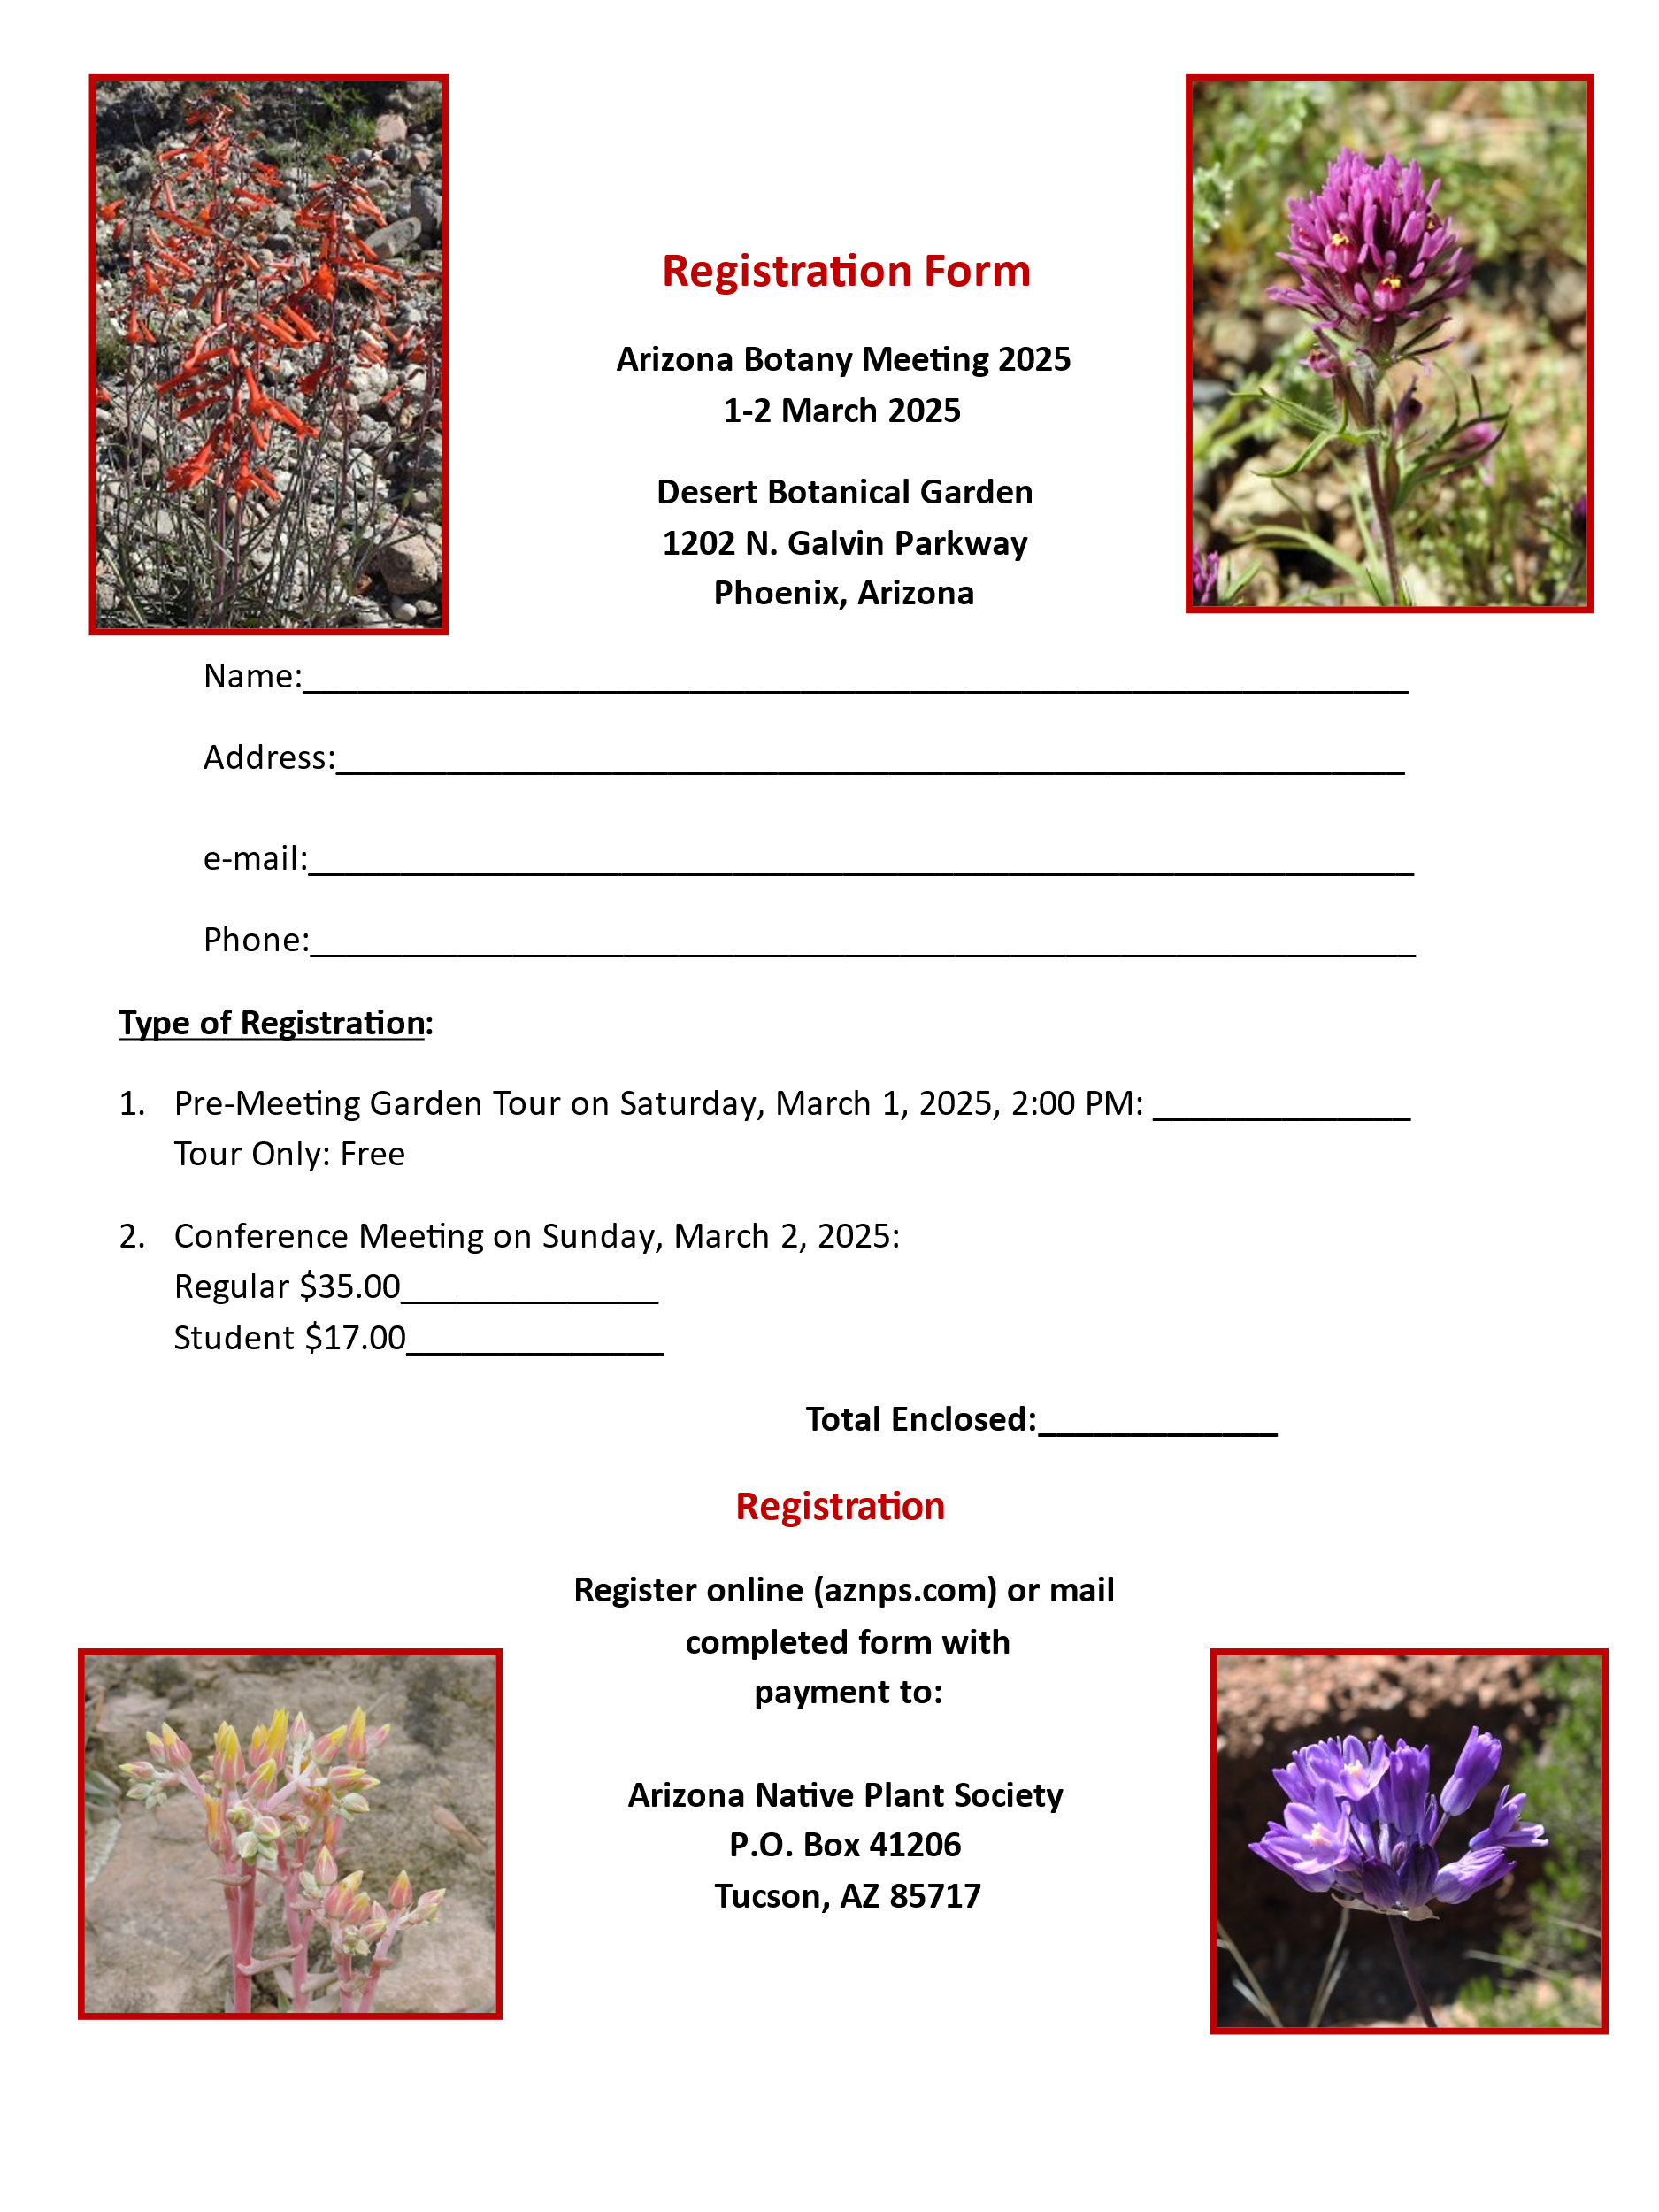

**Panini Options for Lunch**

Please select your choice of panini and bread below. If you are vegan, please check the box for “vegan” also. Thank you!

* **1. West Coaster:** Smoked ham, smashed avocado, arugula, roasted garlic aioli, pickled red onion, Calabrian chili, and feta cheese.

Bread Selection:

* Ciabatta (regular)
* Gluten-Free

* **2. Chicken & Mozzarella:** Grilled chicken, mozzarella, arugula, red onion & sun-dried tomato aioli.

Bread Selection:

* Ciabatta (regular)
* Gluten-Free

* **3. Caprese Pesto:** basil pesto, fresh mozzarella, roma tomato, arugula, balsamic, olive oil

* Vegan

Bread Selection:

* Ciabatta (regular)
* Gluten-Free